Document Title: Engine and Fuel System

Presenter: Zach Sun and Josiah Farinacci

Date:  3/25/25

**Objectives**

* Maximize output
* Lower center of gravity

**Variables**

* Where the engine is mounted

**Component Weight (Carla)**

* Engine (including hardware): 72.1 lbs
* Fuel Tank (including hardware): 5.8 lbs
* Splash Guard: 1 lb
* Total Weight: 78.9 lbs

**Components Needed to be Purchased/ Manufactured**

* Engine (purchase): <https://bajasae.ordertree.com/ch440-e99-gardner-oh-baja-sae/5638692449.p>
* Fuel Tank, Cap, and Fitting (purchase): <https://pyrotectstore.com/product/baja-sae/>
* Fuel Line (purchase): <https://www.amazon.com/Neoprene-Pressure-Automotive-Systems-Engines/dp/B0C16RGFCN?th=1>
* Fuel Cutoff (purchase): <https://www.amazon.com/Inline-Petcock-Pocket-Motorcycle-Generator/dp/B09HS682QX/ref=sr_1_4?crid=JTU81RS6AD8Y&keywords=3%2F16+fuel+cutoff+valve&qid=1698613111&sprefix=3%2F16+fuel+cutoff+valve%2Caps%2C96&sr=8-4>
* Fuel Filter (purchase): <https://www.amazon.com/25-050-21-S1-16-Inch-Diameter/dp/B0021Y2XQM/ref=sr_1_5?adgrpid=1338106223623655&hvadid=83631877562756&hvbmt=be&hvdev=c&hvlocphy=86459&hvnetw=o&hvqmt=e&hvtargid=kwd-83632001867652:loc-190&hydadcr=18707_13465085&keywords=3%2F16%E2%80%9D+fuel+filter&qid=1698789067&sr=8-5>
* Throttle Cable (purchase): <https://www.amazon.com/Throttle-Cable-Enhanced-Casing-Manco/dp/B082XR6SYT/ref=sr_1_26?crid=2IAF6ANNGQXJB&dib=eyJ2IjoiMSJ9.I8tlaBlVyUoro3du1Av5VFjpVV-dIx_wuNg_PizmA3coWH1edMjeklCJA-Vmc8uQoQ6Y1jIc5TmXPc_j0UdhRDNpkV5hhrNn0xUZTOufpzRZXYLFjna0ukatf_28DGairo5y-_H-XeSRR4_7_wiN0TMNC46rsXC8XWO51XZ3WEVWFw3cLNWsxls1rIz4iTLbBGnld4W0dys25DvEpLfuKiJUmN3D9Huu34kiIT06CR4-fXkVD-uqTo1sTD5bj4xOwOzp0bPqwHEGmng-I7zYDCJ8iNMe-KquUz2jF4wKyYw.lRwcwYdxWVF4eAsa1Awlz7fvTuIw7mMjxsQ5UutipfQ&dib_tag=se&keywords=8+ft+throttle+cable&qid=1711034852&sprefix=8+ft+throttle+cable%2Caps%2C81&sr=8-26>
* Splash Guard (manufacture)

**Rules for Engine**

* Required:
  + Kohler CH440 (note: include BAJA restriction plate) (note: cannot use the fuel tank that comes with this engine)
    - Unmodified
    - Four-cycle
    - Air cooled
  + Accepted models: PA-CH440-3302 and PA-CH440-3337
  + Kohler in-line fuel filter
  + Intake and exhaust valve seat angles: 45 deg.
  + Kohler 25 132 19-S spark plugs.
  + Stock Kohler flywheel
  + Governor setting: 3750-3800 RPM
  + 13 mm (.5 in) clearance between any engine throttle and governor linkage and the nearest non-engine obstruction.
  + Governor operation free of obstruction and shielded area.
  + Governor spring engaged with hole 2B. (spring part number: 17 089 64.)
  + The OEM air cleaner for a PA-CH440-3302
  + Access to high speed setting screw (Either: 1.) 3 inch between bolt head and firewall. Or 2.) 0.5 inch hole in the firewall in-line with the bolt head. Hole must be sealed after engine setting with a grommet or sheet metal cover.
  + Unmodified restriction plate.
  + Clear muffler exit. (See picture below). If deflector is used, centerline of muffler exit cross section will be applied to deflector exit port.

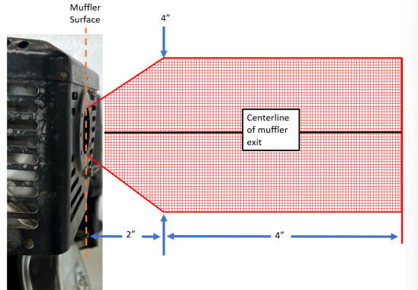

* + Retain OEM protective sheet metal cage surrounding muffler
* Prohibited:
  + Hybrid-electric drivetrain systems
  + Starter motor, battery/electric energy storage, and compressed gas for vehicle propulsion
  + Kinetic energy storage devices (ex. Flywheel)
  + Blueprinting
  + Cleaning or removing aluminum flashing from intake or exhaust ports
  + Altering camshaft, crankshaft, connecting rod, and flywheel
  + Slotting or elongating armature mounting holes to increase or retard ignition timing.
  + Rotating flywheel to advance or retard time
  + Relocation of air filters.
  + Modifying or re-jetting of the carburetor
  + Modifying the carburetor float or venturi.
  + Muffler relocation
  + Starter motor
* Allowed:
  + Hydraulic accumulator for vehicle propulsion
  + Kohler piston rings
  + Any valve clearance between tappet and valve stem.
  + Valves can be lapped for proper sealing.
  + Any armature air gap setting
  + Any idle speed.
  + Changing high speed setting bracket
  + Exhaust deflector
  + Extended starter rope
  + Approved alternator sized in 3, 10 and 18 Ampere versions (resources section on BajaSAE.net)
* Approved Modifications: (see “Engine Resources Section” on BajaSAE.net for more information)
  + High Speed Setting Bracket (fuel tank mount OR low profile)
  + Oil Level Sending Unit Disable
  + Engine modifications per “Baja SAE Conversion Overview”
  + Wiring modifications for kill switch
  + Throttle modifications
  + Charging system installation

**Rules for Fuel System**

* All vehicles shall have a fuel system comprising of a fuel tank, fuel hose and fittings, and splash shields.
* Fuel Tank
  + One fuel tank is permitted.
  + Must be unmodified (no stickers, paint, or other coatings) and free from injurious defects.
  + Only permitted fuel tank is **Pyrotect Part Number SFC1000**, available on the Pyrotect website (http://pyrotectstore.com/shop).
  + Retail price of the fuel tank must be included in the cost report.
  + Note: The fuel tank is anodized by Pyrotect.
* Permitted Fuel
  + Grades of automotive gasoline consisting of hydrocarbon compounds.
  + Fuel may contain anti-oxidants, metal deactivators or corrosion inhibitors.
  + The specific gravity of the fuel may not exceed 0.80 for unleaded gasoline when measured at 15.5 deg. C (60 deg. F).
* Prohibited Fuel
  + Nitrogen bearing additives, or additives designed to liberate oxygen is **explicitly prohibited**.
  + Leaded gasoline is **explicitly prohibited**.
  + Lead alkyl compounds such as tetra-ethyl lead are **explicitly prohibited**.
* Location
  + Entire fuel system (fuel tank, fuel hoses, fuel mounts, carburetor, air cleaner cover, splash shield, and engine must be located within the roll envelope of the vehicle. (Roll envelope is defined as tubing structure, fully welded to the vehicle Roll Cage.)
  + Remote engine air intakes and remote engine air intake hoses are exempt from this rule and may be mounted outside of the roll envelope.
* Required Fuel Cap
  + The fuel cap included with the Pyrotect fuel tank, or a Briggs and Stratton fuel cap with built-in check valve (Part Number: B4325GS), is required.
  + A protective cover may be attached to the fuel cap with adhesive to protect blockage of the vent hole.
* Mounting
  + Fuel tanks shall be mounted to a tube or tubes meeting the requirements of at least a secondary member. Tubes shall be supported at both ends.
  + Cantilevered mounting is **explicitly prohibited**.
  + Removable fuel tanks are **explicitly prohibited**.
  + All mounting holes on the fuel tank must be used to mount the fuel tank to the vehicle frame.
  + All fasteners used to mount the fuel tank shall meet the requirements in Article 12 – Fasteners.
  + A rubber isolating washer, specifically McMaster Carr Part Number 94733A723, shall be used on each fastener, on both sides of the fuel tank mounting flange. A total of 8 rubber washers are required.
  + Metallic washers shall be used on either side of the fastener stack-up, as shown in Figure B-45: Fuel Tank Fastener Stack-up. Metallic washers and bolts shall have a nominal fastener size of 3/8 in. and washers to have an outside diameter between 0.812 in. and 0.875 in.

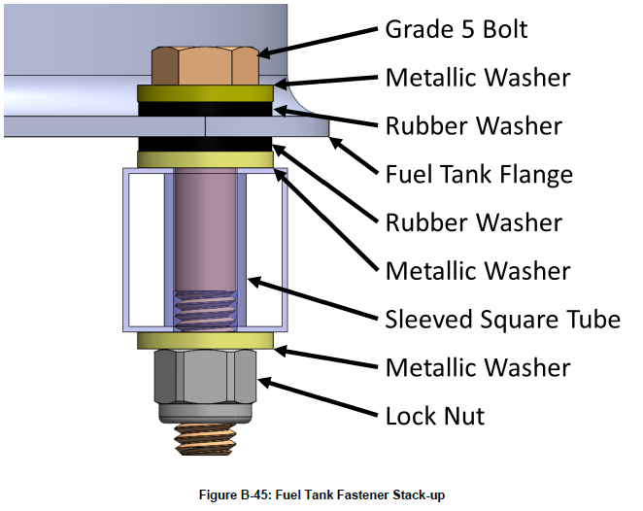

* + The preferred mounting is directly to two square or rectangular tubes with sleeved holes, and meeting the requirements of secondary members.

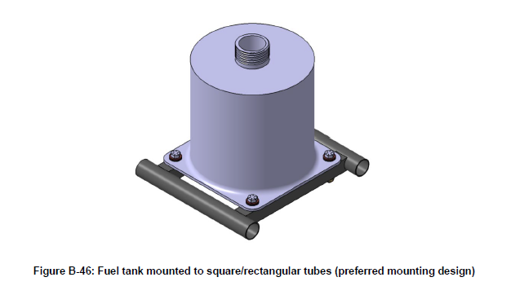

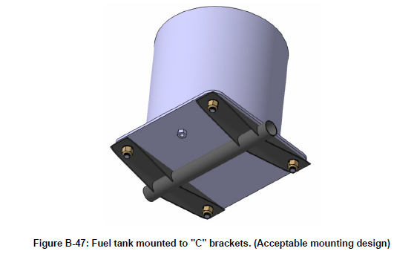

* + Mounting to cantilever brackets (welded to a fully supported secondary frame tube) as shown in Figure B-47 **is acceptable within the following requirements.**
    - 1) Maximum Length: Bracket length may not exceed 101.6 mm (4 in.) from weld-line to center of mounting hole.
    - 2) Minimum edge distance: 14.3 mm (0.5626 in.), measured from the edge of the bolt hole to the nearest outside edge of tab, and 12.7 mm (0.375 in) from the edge of the bolt hole to the nearest bend tangency. If using square tubing to form the brackets, a minimum 31.75 x 1.6mm (1.25 x 0.0623 in) tubing shall be used.
    - 3) Allowable cross section: Brackets shall have a “C” cross-section. The supporting gussets may be tapered as shown in Figure B-48, and shall be a minimum 22.9 mm (0.9 in) tall at the weld. Flat brackets are **not permitted**.

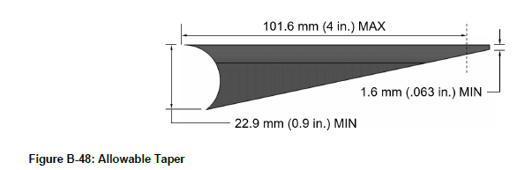

* + - 4) Minimum Thickness: 1.6 mm (0.063 in.)
    - 5) Minimum Weld Length: At least the full outside face of the bracket must be welded to the supporting tube as shown in Figure B-49.

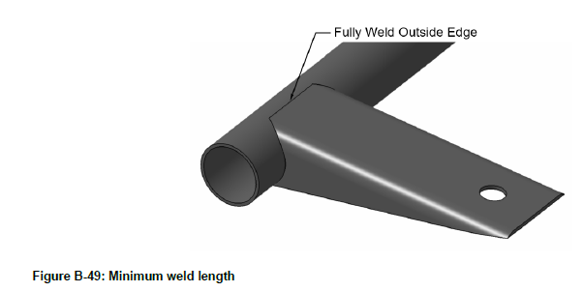

* + - 6) Lightening holes our cutouts other than the bolt hole are explicitly prohibited.
* Fuel Lines and Filters
  + Location
    - Grommeting is required where the lines pass through any member of the vehicle.
    - Fuel lines **are prohibited in the cockpit.**
    - Fuel lines shall have sufficient slack to not be held in tension.
    - Fuel lines shall be secured to fittings with SAE Size #4 adjustable metal clamps or Kohler OEM clamps.
    - Any breaks (discontinuities) in the fuel line, including those for fuel fittings such as filters, sensors, or cut-out valves shall be located above the spill pan.
    - The fuel line shall be continuous between the last connection above the spill pan and the carburetor. The fuel line should pass around the spill pan or if the fuel line passes through the splash shield the fuel line shall be able to freely move up and down. Any attachment points below the spill pan not directly mounted to the engine shall allow the fuel line to freely move up and down.
    - Note: To provide strain relief for the fuel line, it is recommended to attach a snug fit clamp to the engine that matches the OD of the fuel line. Example McMaster-Carr part #3177T52.
  + Rating
    - All fuel lines shall be SAE J30 rated fuel lines and bear appropriate OEM labels with rating information.
  + Size
    - All fuel lines shall be “3/16 inch” (trade size).
  + Fuel Filters
    - A Kohler in-line fuel filter is required and shall be located above the splash shield. No more than one (1) fuel filter may be used at a time.
  + Fuel Sensors
    - Fuel level gauges and sensors are allowed as long as the fuel tank is not modified. Fuel level gauges and sensors are allowed such that the capacity of the fuel system is not increased.
  + Fuel Pumps
    - Fuel pumps are prohibited.
  + Splash Shields
    - Splash shields are required
    - The splash shield must be made of metallic material (greater than 0.5 mm or 0.02 inches thick). An example arrangement of splash shielding is shown in two views in Figure B-50.
    - Must be non-adjustable.
    - Must be mounted lower than the structural member supporting the fuel tank.
    - Must have a minimum clearance of 13 mm (0.5 in) to the exhaust and must not be impinged upon by exhaust gases.
    - If the fuel line passes through the splash shield, it must pass through a sealed, grommeted hole in the shield to prevent fuel from leaking on the engine.
    - **Bulkhead fittings are not permitted.**

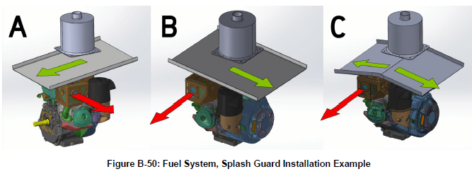

* + Approved Fuel Containers for Transporting Fuel into Fuel Tanks
    - Have a volume of 5.7 L (1.5 gal.) or less for fueling vehicles during endurance event.
    - Have a volume of 21.2 L (5.6 gal.) or less for all other capabilities.
    - Have an original cap to prevent spills.
    - Be labeled with school name and car number.
    - Teams are required to bring all fuel to the fueling zone during the endurance event, see rule D.8.3.7 - Refueling.
  + Fuel Tank Access Panels
    - An observer directly behind the vehicle must have an unobstructed view of the fuel tank and associated components.